 | 26.2 Editors - Properties Editor - Render Properties Tab
Table of content
Detailed Table of content 1
Render Tab 5
Sampling panel 5
Depth of Field panel 5
Horizon Scan 6
Raytracing panel 6
Volumes panel 11
Performance panel 12
Curves panel 12
Lights panel 12
Shadows panel 12
Light Probes 13
Motion Blur panel 13
Film panel 15
Simplify panel 16

Detailed Table of content

Detailed table of content
Detailed Table of content 1
Render Tab 5
Sampling panel 5
Viewport subtab 5
Samples 5
Temporal Projection 5
Render subtab 5
Samples 5
Depth of Field panel 5
Max Size 5
Sprite Threshold 5
Neighbor Rejection 5
Jitter Camera 5
Overblur 6
Horizon Scan 6
Precision 6
Thickness 6
Bias 6
Raytracing panel 6
Method 6
None 6
Screen-Trace 6
Settings 6
Unified 7
Reflection / Refraction / Diffuse subpanel 7
Resolution 7
Clamp 7
Screen Tracing subpanel 7
Precision 7
Thickness 7
Denoising Subpanel 7
Denoising 7
Spatial Reuse 7
Temporal Accumulation 7
Bilateral Filter 7
Split 8
Reflection subpanel 8
Resolution 8
Clamp 8
Screen Tracing subpanel 8
Precision 8
Thickness 8
Denoising Subpanel 8
Denoising 8
Spatial Reuse 8
Temporal Accumulation 8
Bilateral Filter 8
Refraction subpanel 9
Resolution 9
Clamp 9
Screen Tracing subpanel 9
Precision 9
Thickness 9
Denoising Subpanel 9
Denoising 9
Spatial Reuse 9
Temporal Accumulation 9
Bilateral Filter 9
Diffuse subpanel 10
Resolution 10
Clamp 10
Screen Tracing subpanel 10
Precision 10
Thickness 10
Denoising Subpanel 10
Denoising 10
Spatial Reuse 10
Temporal Accumulation 10
Bilateral Filter 10
Volumes panel 11
Start 11
End 11
Tile Size 11
Samples 11
Distribution 11
Max Depth 11
Volumes Lighting subpanel 11
Enable 11
Light Clamping 11
Volumetric Shadows subpanel 11
Enable 11
Samples 12
Performance panel 12
High Quality Normals 12
Curves panel 12
Shape 12
Additional Subdiv 12
Lights panel 12
Light Threshold 12
Shadows panel 12
Enable 12
Pool Size 12
Rays 13
Steps 13
Normal Bias 13
Light Probes 13
Sphere subtab 13
Resolution 13
Volume subtab 13
Pool Size 13
Bake Volumes 13
Delete Light Cache 13
Motion Blur panel 13
Enable 14
Position 14
Background Separation 14
Steps 14
Shutter Curve 14
Navigation elements 14
Zoom in and out 14
Tools 14
Reset View 14
Vector Handle 14
Auto Handle 14
Auto Clamped Handle 14
Extend Horizontal 14
Extend Extrapolated 14
Reset Curve 15
Use Clipping 15
Delete Points 15
X and Y values 15
Presets 15
Film panel 15
Filter Size 15
Animate Property 15
Overscan 15
Overscan Size 15
Simplify panel 16
Enable 16
Viewport 16
Max Subdivisions 16
Child Particles 16
Volume Resolution 16
Shadow Resolution 16
Animate Property 16
Render 16
Max Subdivisions 16
Child Particles 16
Shadow Resolution 17
Animate Property 17
Grease Pencil 17
Enable 17
Playback Only 17
Fill 17
Modifiers 17
Shader Effects 17
Layers Tinting 17
Antialiasing 17

Render Tab
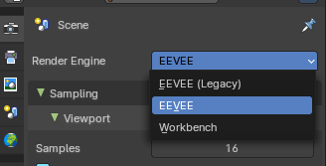
There are four different render engines available. Workbench, EEVEE, EVEE (Legacy), and Cycles. This chapter has a focus on the EEVEE render engine.

Sampling panel
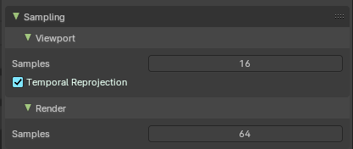

Viewport subtab

Samples
The number of samples when rendering in the viewport.

Temporal Projection
Denoise image using a method called temporal reprojection. This method can leave some ghosting.

Render subtab

Samples
The number of samples when rendering to file.

Depth of Field panel
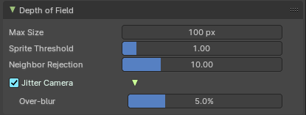

Max Size
The maximum size of the bokeh shape for Depth of Field. Lower is faster.

Sprite Threshold
Brightness threshold for using sprite base depth of field.

Neighbor Rejection
The maximum brightness to consider when rejecting bokeh sprites based on neighborhood. Lower is faster.

Jitter Camera
Jitter the camera to create accurate blurring by using render samples.

Overblur
Apply blur to each jittered sample to reduce undersampling artifacts.

Horizon Scan
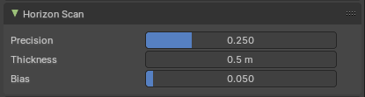
Horizon scan is a new way of computing occlusion using visibility bitmask.

Precision
The precision of the horizon scan.

Thickness
Constant thickness of the surfaces considered when doing horizon scan and by extension ambient occlusion.

Bias
The bias horizon angles to reduce self intersection artefacts.

Raytracing panel

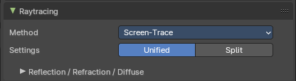

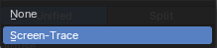
Method
Select the tracing method to find scene-ray intersections.

None
Do nothing.

Screen-Trace
Raytracing against the depth buffer.

Settings
The split settings per ray type

Unified
All ray types use the same settings.
As a consequence there is just one panel for all of the ray types.

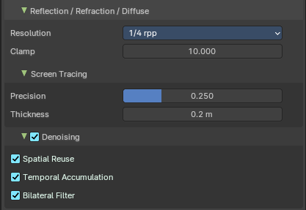
Reflection / Refraction / Diffuse subpanel
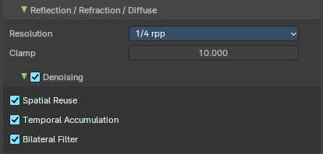

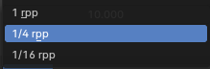
Resolution
Number of rays per pixel

Clamp
Clamp ray intensity to reduce noise. 0 to disable.

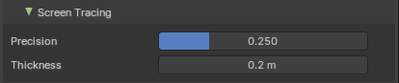
Screen Tracing subpanel
Just available with method Screen-Trace.

Precision
The precision of the screen space ray-tracing.

Thickness
Pixel thickness used to detect intersections.

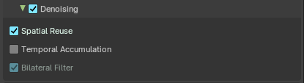
Denoising Subpanel

Denoising
Enable Denoising for raytraced effects.

Spatial Reuse
Reuse the rays of neighbour pixe.

Temporal Accumulation
Accumulate samples by reprojecting last tracing results

Bilateral Filter
Blur the resolved radiance by reprojecting last tracing result of the temporal accumulation.

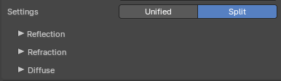
Split
Settings are individual to each ray type. So there is a subpanel for each ray type then. With basically the same content.

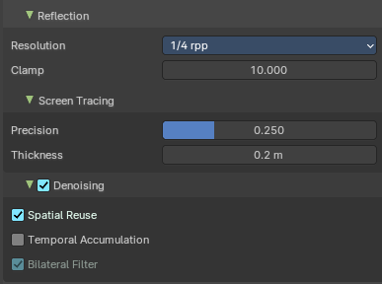
Reflection subpanel
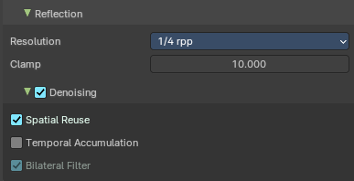

Resolution
Number of rays per pixel

Clamp
Clamp ray intensity to reduce noise. 0 to disable.

Screen Tracing subpanel
Just available with method Screen-Trace.

Precision
The precision of the screen space ray-tracing.

Thickness
Pixel thickness used to detect intersections.

Denoising Subpanel

Denoising
Enable Denoising for raytraced effects.

Spatial Reuse
Reuse the rays of neighbour pixe.

Temporal Accumulation
Accumulate samples by reprojecting last tracing results

Bilateral Filter
Blur the resolved radiance by reprojecting last tracing result of the temporal accumulation.

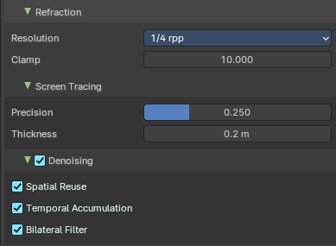
Refraction subpanel
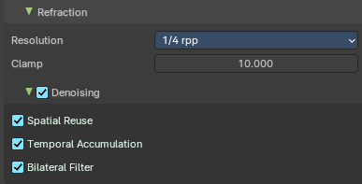

Resolution
Number of rays per pixel

Clamp
Clamp ray intensity to reduce noise. 0 to disable.

Screen Tracing subpanel
Just available with method Screen-Trace.

Precision
The precision of the screen space ray-tracing.

Thickness
Pixel thickness used to detect intersections.

Denoising Subpanel

Denoising
Enable Denoising for raytraced effects.

Spatial Reuse
Reuse the rays of neighbour pixe.

Temporal Accumulation
Accumulate samples by reprojecting last tracing results

Bilateral Filter
Blur the resolved radiance by reprojecting last tracing result of the temporal accumulation.

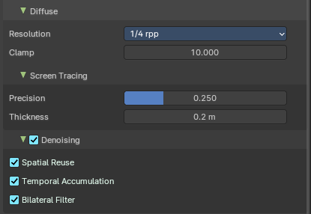
Diffuse subpanel
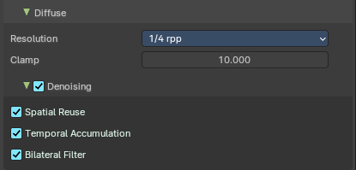

Resolution
Number of rays per pixel

Clamp
Clamp ray intensity to reduce noise. 0 to disable.

Screen Tracing subpanel
Just available with method Screen-Trace.

Precision
The precision of the screen space ray-tracing.

Thickness
Pixel thickness used to detect intersections.

Denoising Subpanel

Denoising
Enable Denoising for raytraced effects.

Spatial Reuse
Reuse the rays of neighbour pixe.

Temporal Accumulation
Accumulate samples by reprojecting last tracing results

Bilateral Filter
Blur the resolved radiance by reprojecting last tracing result of the temporal accumulation.

Volumes panel

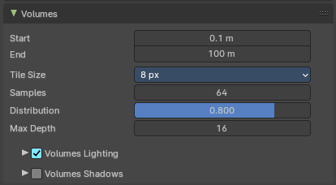
Contains volumetrics settings.

Start
The start distance for volumetrics.

End
The end distance for volumetrics.

Tile Size
The quality of the volumetrics effect. The lower the size the higher the quality and ram usage.

Samples
Number of samples to compote for the volumetrics effect.

Distribution
Distribute more samples closer to the camera.

Max Depth
Maximum surface intersection count used by the accurate volume intersection method. Thise feature will create artifacts if it is exceeded.

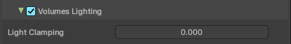
Volumes Lighting subpanel

Enable
In the header you will find a checkbox to enable Volumetric Lighting.

Light Clamping
The maximum light contribution.

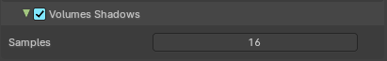
Volumetric Shadows subpanel

Enable
In the header you will find a checkbox to enable Volumetric Shadows.

Samples
Number of samples to compute volumetric shadowing.

Performance panel
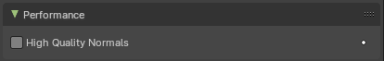

High Quality Normals
Use high quality tangent space. Slower but more accurate.

Curves panel

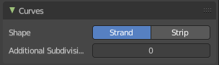
Shape
Choose if the hair is displayed as strand or as strip.

Additional Subdiv
Additional subdivision along the hair.

Lights panel
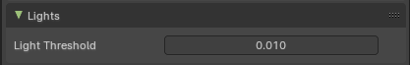

Light Threshold
Minimum Light intensity for a light to contribute to the lighting.

Shadows panel
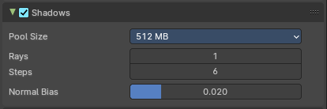
Contains settings regarding shadows.

Enable
The checkbox in the header enables shadows and its settings.

Pool Size
Size of the shadow pool. A bigger pool size allows for more shadows in the scene. But might not fit into the GPU memory of your graphics card.

Rays
Amount of shadow ray for each light.

Steps
Amount of shadow map sample per shadow ray.

Normal Bias
Move along their normal.

Light Probes
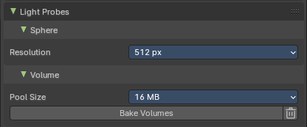
Light probes are precalculated lights to speed up rendering.

Sphere subtab

Resolution
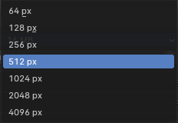
The size of the cubemaps in pixels. Precalculated light gets stored in cubemaps.

Volume subtab

Pool Size
The size of the irradiance pool. A bigger pool allows for more irradiance grid in the scene. But might not fit into the GPU memory, and decrease performance.

Bake Volumes
Bake all light probe volumes.

Delete Light Cache
Deletes the baked light cache.

Motion Blur panel
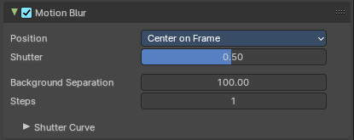
Enable Motion Blur and adjust the settings.
Each object has also its own settings to control motion blur. These options can be found in the corresponding Object tab of the Properties editor.

Enable
In the header is a checkbox to enable Simplify.


Position
Controls at what point the shutter opens in relation to the frame.

Background Separation
Lower values will reduce background bleeding onto foreground elements.

Steps
Controls the accuracy of motion blur. More steps means longer render time.

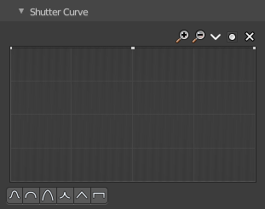
Shutter Curve
Sutter curve is a sub menu wAdjust a curve for the shutter effect.

Navigation elements
The navigation elements at the top are described from left to right.

Zoom in and out
The two buttons with the magnifying glass at it zooms in and out in the curve window.

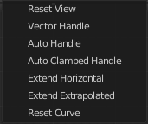
Tools
Tools is a menu that contains some curve related tools.

Reset View
Resets the curve windows zoom.

Vector Handle
Set handle type to Vector.

Auto Handle
Set handle type to Auto.

Auto Clamped Handle
Set handle type to Auto Clamped.

Extend Horizontal
Causes the curve to stay horizontal before the first point and after the last point.

Extend Extrapolated
Causes the curve to extrapolate before the first point and after the last point, based on the shape of the curve.

Reset Curve
Resets the curve to the initial shape.


Use Clipping
Clipping options. Set up clipping for the stroke.

Delete Points
Deletes selected curve points.

X and Y values
The coordinates of the currently selected curve point.

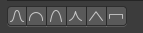
Presets
At the bottom you can find some curve presets.

Film panel
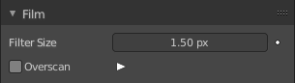

Filter Size
The width over which the reconstruction filter combines samples.

Animate Property
This property can be animated. Activating this button sets a keyframe.

Overscan
Internally render past the image borders to avoid screen space effects disappearing.

Overscan Size
How much bigger the image should be internally rendered.

Simplify panel
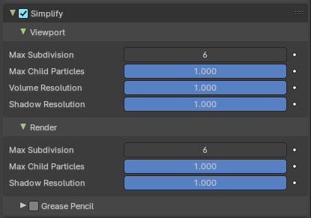
Sometimes you want to simplify the rendering without to loose the already tweaked settings and adjustments. For test renderings for example. Simplify allows you to simplify the rendering.

Enable
In the header is a checkbox to enable Simplify.

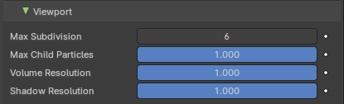
Viewport
This section affects the rendering with Eevee in the Viewport.

Max Subdivisions
Limit the number of maximum subdivisions.

Child Particles
Limit the number of child particles.

Volume Resolution
Simplify volumes by setting the resolution percentage of volume objects in viewport.

Shadow Resolution
The shadow resolution in percentage.

Animate Property
This properties can be animated. Activating this button sets a keyframe.

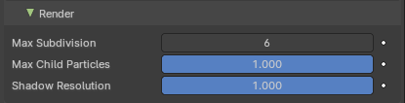
Render
This section affects the rendering with Eevee to file.

Max Subdivisions
Limit the number of maximum subdivisions.

Child Particles
Limit the number of child particles.

Shadow Resolution
The shadow resolution in percentage.

Animate Property
This properties can be animated. Activating this button sets a keyframe.

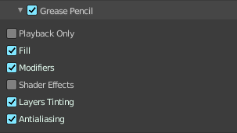
Grease Pencil
This section affects Grease Pencil drawings.

Enable
Enables the Grease Pencil features.

Playback Only
Simplify Grease Pencil only during animation playback.

Fill
Display Fill strokes in the Viewport.

Modifiers
Apply modifiers in the viewport.

Shader Effects
display shader effects.

Layers Tinting
Display layers tint.

Antialiasing
Use antialiasing to smooth stroke edges.

